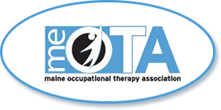
2022 MONTHLY STATUS REPORT
To: MeOTA
From: Kate Brooks
Subject: March 2022
ACTIVITIES COMPLETED IN THE PAST MONTH
Completed Deliverables:. Craft Night, Reading and Reflection Circle, March Region update email
ACTIVITIES IN PROCESS |  | NEXT ACTION | DUE DATE
- Recruitment email for N. ME rep |  | - send to Northern Maine constituents | - 4/15/22
- Getting Fox Rehab for sponsorship/presenter for conference |  | - send correspondence to appropriate person | - 4/15/22
- Contacting WSCH6 for spot highlighting OT for OT month |  | - have heard back from my contact and she has passed my info along - just waiting to hear back from the person in charge | - 3/30/22
ACTIVITIES TO BE STARTED WITHIN THE NEXT MONTH
- . Organizing next social for Southern region
LONG TERM PROJECTS
- Membership ad hoc committee
- Website ad hoc committee
ISSUES FOR IMMEDIATE ATTENTION
- n/a

